© IPSF 2019 | All rights reserved.
Substance use disorder education report - A glance on the current educational needs of pharmacy students
Substance use disorder education report - A glance at the current educational needs of pharmacy students
¹Karen Abboud, ¹Rosary Pang, ¹Ana-Katharina Gehrke, ¹Luka Tomasic, ¹Kenny Sidharta, ¹Fatma Mohamed, ¹Daniel Semmy
¹Pharmacy Education Committees, International Pharmaceutical Students' Federation (education@ipsf.org)
Abstract
Substance use disorders (SUD) constitute a cluster of substance-related psychological and behavioural disorders that have been increasingly shown to contribute to the global burden of disease. It has been demonstrated that patients rarely receive adequate treatment. Pharmacists, touted as the most accessible healthcare professionals, can identify affected individuals in the community and facilitate access to optimal treatment. We conducted an international cross-sectional study to assess pharmacy students’ perspectives regarding the extent of the current pharmacy curricula in preparing students to tackle substance use disorders in their professional practices. After 279 responses from over 31 countries were collected, we concluded that more emphasis should be placed on this seminal topic in terms of hours, topics covered, and experiential opportunities provided to develop more confident pharmacists capable of addressing this global health concern.
Keywords: substance use disorders (SUD), education

Background
Substance use disorders (SUD) are associated with substantial morbidity and the highest mortality among all mental and behavioural disorders. The mortality ratio, compared to the general population, is about 15 times higher for opioid use disorders, about six times higher for amphetamine use disorders, and about five times higher for alcohol use disorders.¹ Substance use contributes substantially to the global burden of disease not only through substance use disorders, but also through unintentional injuries, suicide, cancers, cirrhosis, and the complications of chronic hepatitis C infection.²
This major cause of global disability has been acknowledged in the United Nations Sustainable Development Goals (SDGs), where prevention and treatment of substance use disorders have been incorporated in the targets.³ It has been demonstrated that only a small proportion of people with substance use disorders receive adequate treatment. ³
Geographically, Eastern Europe has the highest prevalence and age-standardised attributable burden of alcohol and tobacco consumption, followed by southern Sub-Saharan Africa; the highest age-standardised attributable burden for drug use, namely opioids, cannabis, and cocaine, is in high-income North America.^{2,4} The high attributable burden, even in high-income countries, can be explained by low treatment rates, delays in starting treatment, and stigma.⁴ Barriers to treatment include lack of awareness of treatment needs, access to treatment once a need is recognised, and adherence to treatment. ³
Pharmacists are universally renowned as the most accessible healthcare professionals. They assess the appropriateness of medications, counsel patients, and monitor medication safety and efficacy parameters. Health-system pharmacists implement and oversee a safe and effective medication-use system, including legal and organisational responsibilities for medication distribution and control across the continuum of practice settings within healthcare organisations. With this combination of specialised medication knowledge and organisational responsibilities, pharmacists are well-positioned to help in substance abuse prevention, education, and treatment. Despite the potential for a significant positive impact by pharmacists, published data regarding the role of pharmacists in managing SUD in most countries are scarce.
Recognising the important role of pharmacists in providing care to patients with SUDs, the American Association of Colleges of Pharmacy (AACP) special committee on substance abuse and pharmacy education have updated and revised the document “Curricular Guidelines for Pharmacy: Substance Abuse and Addictive Disease” in 2010 and suggested that “at least 4 hours be devoted to the identification, intervention, and treatment of addiction and related disorders,” which “should prepare the student pharmacist to competently problem-solve issues concerning alcohol and other drug abuse and addictive diseases affecting patients, families, colleagues, themselves, and society.”¹⁰ Guidelines promoting the incorporation of SUDs in pharmacy schools in other countries are lacking.
Similarly, data regarding pharmacy students’ training in SUDs is scarce and limited to North America. In a study published by the Center on Addiction and Substance Abuse (CASA) in 2005, only 48% of the 1,030 registered pharmacists surveyed received any training in preventing drug diversion. Moreover, only 49% received training in identifying abuse or dependence since graduation. The CASA study also revealed that only about half of the pharmacists surveyed rated the substance abuse education and training they received in college as good or excellent. ¹¹ In a more recent survey of US pharmacy programs, 94% of respondents reported teaching SUDs during the 2014-15 academic year curriculum with the majority (56%) delivering SUD content during year 3 of pharmacy school, 31% teaching in year 2, and only 3% reported teaching during year 1. The average time of instruction reported was 2.7 hours (SD = 1.5 hours) with 79% of programs reporting at least 2 hours and only 30% of the programs teaching ≥4 hours. ¹²
We sought to examine the status of pharmacy students' education on substance use disorders and pinpoint areas of improvement to allow pharmacists to assume their significant role in the management of substance use disorders.
Method
A qualitative cross-sectional study was conducted by distribution of an email survey. The target population of this study were the members of the International Pharmaceutical Students' Federation (IPSF), which is comprised of pharmacy students and recent graduates of up to 4 years after graduating (see Appendix). Responses were accepted from January 24 to March 20, 2019. The survey collected demographic data as well as information regarding the delivery and content of curricula in relation to SUD and application of learned concepts. Confidence in managing SUD patients was assessed using a Likert scale.
Results and Analysis
Data was collected from 279 members from 31 countries which completed the survey, including Vietnam (23.3%), Iraq (7.9%), Kenya (7.9%), Tanzania (7.5%), Rwanda (5%), Lebanon (3.2%), and Malaysia (2.5%). 36.9% of respondents were from Asia Pacific Regional Office (APRO), 34.1% were from African Regional Office (AfRO), 12.5% were from Eastern Mediterranean Regional Office (EMRO), 11.1% were from European Regional Office (EuRO), and 5.4% were from Pan American Regional Office (PARO). 59.9% were enrolled in a 5-year program and half, 50.9%, were in year 4 or further along their studies.
26.5% were falling short of the recommended 3-4 hours of instruction by U.S. psychiatric pharmacists and AACP respectively. 42.3% of students are first introduced to SUDs in year 4 or 5 while the 2010 AACP curricular guidelines recommend that teaching psychosocial aspects of alcohol and other drug use should be “initiated within the first 3 semesters of the pharmacy curriculum within required courses”. The majority of programs rely on didactic lectures and less than half utilise interactive teaching methods such as small group discussions, flipped classrooms model, simulations, and case-based learning which have demonstrated increased efficacy in learning. (See figure 1) The experiential component inherent to pharmacy education is not being sufficiently practiced since experiential training in psychiatric wards was reported by 13.6% of respondents. However, it is possible that some substance use disorders may be encountered in other practice settings, such as emergency medicine and internal medicine rotations, and that is demonstrated by the fact that 56.3% of respondents did encounter SUDs in their experiential courses. 38.7% reveal no collaboration with other departments such as hospitals, NGOs, ministries of health, and rehabilitation centers that would enable students to get exposed to actual patients and their management. Collaboration with regulatory bodies such as the Ministry of Health and Drug Enforcement Administration could show students how to establish a controlled-substance inventory system in compliance with regulatory requirements that deters diversion and promotes accountability. It could also show them how to participate in proper prescription disposal programs, how to comply with reporting regulations, and how to contribute to investigations concerning the misuse of controlled substances, especially within a healthcare system.
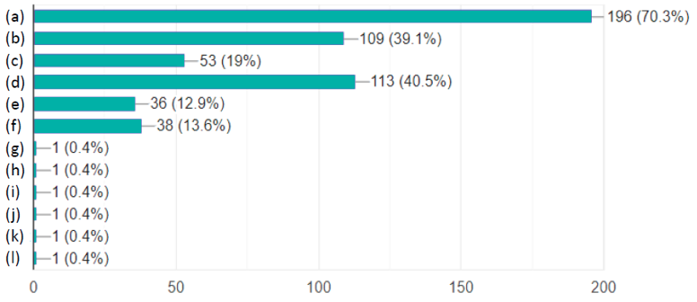
Figure 1 Teaching techniques that institutions use in SUD education (a) Didactic lectures, (b) Small group discussions, (c.) Flipped classroom, (d) Case-based learning, (e) Simulations, (f) Experiential training in psychiatric wards, (g) Making awareness videos and campaigns, (h) Self-directed learning, (i) Group presentations, (j) Does not know, (i) SUD is not in education module
Moreover, 54.8% do not receive any education in an interprofessional environment while SUD management often requires collaboration from different healthcare professionals including physicians, nurses, psychologists, social workers and others. On a more positive note, 95% of respondents reported engagement in community interactive techniques encouraged by their programs such as awareness campaigns, outreach activities, seminars, and conferences. These community outreach activities help promote the role of the pharmacist in participating in or contributing to the development of substance abuse prevention and assistance programs within healthcare organisations and public places (e.g., in primary and secondary schools, colleges, places of worship, and civic organisations). Also, respondents received uneven instruction on disorders concerning substances pertinent to SUDs, including alcohol (79.2%), opioids (79.2%), sedatives/hypnotics (77.1%), tobacco (62.7%), cocaine (60.6%), hallucinogens (59.6%), amphetamines (55.6%), and cannabis (50.5%). Ideally, all students should have been educated on substance use disorders to be able to participate in their management.
While the data showed that a majority of students (82.8%) are able to describe the major pharmacological and toxicological properties of alcohol and commonly abused drugs and related substances, other aspects of SUDs need to be reinforced in the curriculum. The neurobiology of addiction (45.2%) should be better emphasised so that students can recognise addiction as a disease and resolve the stigma surrounding it. The clinical characteristics of acute and chronic intoxication and withdrawal (64.5%) and screening and diagnostic criteria (41.2%) should be emphasised more as pharmacists, at the frontline of primary care, can identify impairment and suggest assistance resources for individuals affected by addiction and related disorders. Furthermore, pharmacotherapeutic treatment (68.8%) should also be reinforced as pharmacists, the medication experts, can collaborate with other healthcare providers to develop drug detoxification protocols and provide pharmaceutical care to patients. Psychosocial treatment (33%) and patient counseling (45.2%) should feature in all curricula as well because pharmacists have an essential role in counselling individuals who are recovering from addictive diseases in terms of the appropriate use of herbal remedies and supplements, nonprescription and prescription drugs. For fruitful interactions with patients with mental illnesses and SUDs, specific training in motivational interviewing and Mental Health First Aid (MHFA) may be useful. MHFA is an 8-hour course that promotes mental health awareness and helps in identifying and addressing signs of mental illness. ¹⁶
To highlight pharmacists’ impactful role as counselors, recent evidence suggests that pharmacists' advice on smoking cessation can produce significant increases in quit rates among smokers.⁸ The addition of a clinical pharmacy specialist (CPS) as a bridge until the next available mental healthcare provider appointment would improve access to Alcohol Use Disorder pharmacotherapy for patients in the intensive outpatient program (IOP) and provide medication education to patients and providers.¹⁴ Outpatient pharmacotherapy for addiction, ranging from nicotine transdermal patches, naltrexone, and disulfiram for alcoholism to buprenorphine and OAT for opioid dependence, is becoming more common. Medications have shown efficacy, but uptake and adherence are very low. Pharmacists can help counsel on the importance of therapy and adherence. Opioid agonist therapy (OAT) reduces opioid use, improves physical and mental wellbeing, and reduces mortality.⁴ While guidance from Europe and the USA highlights the importance of access to evidence-based, quality integrated treatment with OAT, provision and access to integrated treatment programs for opioid use disorder (OUD) is often limited due to fears of misuse and diversion of OAT products. New formulations of OAT medications, such as injected or depot forms of buprenorphine, may limit misuse and diversion. Other reasons for limited access to OAT as medical maintenance therapy in integrated programs include the lack of effective medical drug distribution systems and unreliable product supply, and limited resources for patient supervision. All these issues can be addressed by pharmacists.⁷
Moreover, 58.8% of respondents have taken courses that shed light on the important role of pain management in controlling SUDs and countering "addiction phobias" for those patients (e.g., hospice patients) who require significant pain control but fear becoming addicted to the prescribed medication. 54.8% and 46.6% of respondents have covered patients with chronic pain and cancer patients, respectively. Clearly, the role of effective pain management, especially in susceptible populations should be emphasised more to mitigate the risk for substance abuse. (See figure 2)
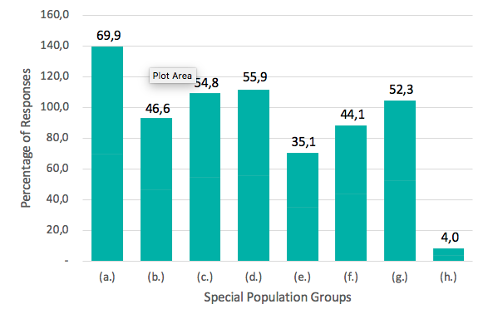
Figure 2 Percentage of special population covered in SUD curricula. (a) patients with SUDs, (b) cancer patients, (c) patients with chronic pain, (d) patients with environmental risk factors of developing SUD, (e) patients undergoing surgeries, (f) patients with sleeping disorders, (g) patients with mental illnesses, (h) other population
The most common interactive techniques used in educational institutions about SUDs include awareness campaigns and outreach activities (65.6 %), seminars, (57.3%), public education videos (38%), and flyers (26.5 %). Finally, on a Likert scale of 1 to 5, only 30.8% of students feel confident or very confident in managing SUD patients. The majority of respondents (40.5%) are somewhat confident in SUD management. This lingering hesitation attests to the need to provide a more extensive education in SUD and more opportunities for practical training (See figure 3).
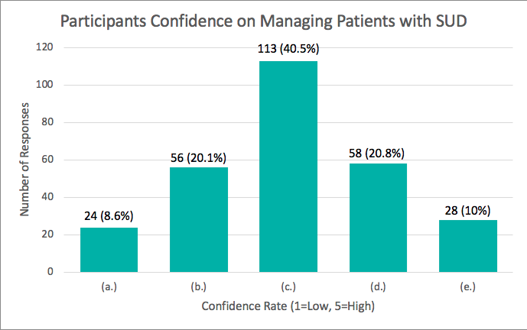
Figure 3 Survey participants’ confidence in managing patients with SUD. (a) 1; Not confident at all (b) 2 (c) 3 (d) 4 (e) 5; Very confident
This survey was intended to be a snapshot portraying the current education and training which pharmacy students and recent graduates of up to four years worldwide receive in SUD. The limitations of this study include a small sample size and an unequal distribution of responses from different regions which decreases the generalizability of the collected data to the global education status of pharmacy students and recent graduates. Research is needed to produce global standards in SUD education that strengthen the quality of SUD instruction and contribute to alleviating this global public health burden.

Conclusion
Pharmacists need to be properly equipped to screen, assess, refer patients to appropriate levels of care, collaborate with physicians in designing the pharmacotherapy plan, and provide appropriate counseling about adequate medication use and side effects. In order to do so, SUD education should be started earlier in pharmacy school and be given more emphasis in pharmacy curricula in terms of hours, extent of disorders, aspects of addiction, diagnosis, management, and counseling covered, populations addressed, and experiential training opportunities provided. Students should also take the initiative to further their knowledge of SUDs as it is a pressing and highly prevalent issue, and locate local and accessible substance abuse and harm reduction organisations to get involved with and foster the necessary skills to become more confident in assisting these patients on their road to recovery.
References
- WHO Forum on alcohol, drugs and addictive behaviours. Alcohol and drug use disorders: Global Health Estimates. Alcohol and drug use disorders: Global Health Estimates. 2017. https://www.who.int/substance_abuse/activities/fadab/msb_adab_2017_GHE_23June2017.pdf?ua=1
- Peacock A, Leung J, Larney S, et al. Global statistics on alcohol, tobacco and illicit drug use: 2017 status report. Addiction. 2018;113(10):1905-1926. doi:10.1111/add.14234Degenhardt L, Glantz M, Evans-Lacko S, et al. Estimating treatment coverage for people with substance use disorders: an analysis of data from the World Mental Health Surveys. World Psychiatry. 2017;16(3):299-307. doi:10.1002/wps.20457
- Peacock A, Leung J, Larney S, et al. Global statistics on alcohol, tobacco and illicit drug use: 2017 status report. Addiction. 2018;113(10):1905-1926. doi:10.1111/add.14234Degenhardt L, Glantz M, Evans-Lacko S, et al. Estimating treatment coverage for people with substance use disorders: an analysis of data from the World Mental Health Surveys. World Psychiatry. 2017;16(3):299-307. doi:10.1002/wps.20457
- Degenhardt L, Charlson F, Ferrari A, et al. The global burden of disease attributable to alcohol and drug use in 195 countries and territories, 1990–2016: a systematic analysis for the Global Burden of Disease Study 2016. The Lancet Psychiatry. 2018;5(12):987-1012. doi:10.1016/s2215-0366(18)30337-7.
- Wahaibi NA, Lawati AA, Ruqeishy FA, et al. The characteristics and patterns of utilization of healthcare services among Omanis with substance use disorders attending therapy for cessation. Plos One. 2019;14(1). doi:10.1371/journal.pone.0210532
- Ghaferi HAA, Ali AY, Gawad TA, Wanigaratne S. Developing substance misuse services in United Arab Emirates: the National Rehabilitation Centre experience. BJPsych International. 2017;14(4):92-96. doi:10.1192/s2056474000002105
- ElKashef, A., Alzayani, S., Shawky, M., Al Abri, M., Littlewood, R., Qassem, T., Alsharqi, A., Hjelmström, P., Abdel Wahab, M., Abdulraheem, M. and Alzayed, A. (2018). Recommendations to improve opioid use disorder outcomes in countries of the Middle East. Journal of Substance Use, 24(1), pp.4-7.
- Smith MD, McGhan WF, Lauger G. Pharmacist counseling and outcomes of smoking cessation. American Pharmacy. 1995;NS35:20–9.
- Tommasello AC. Substance abuse and pharmacy practice: what the community pharmacist needs to know about drug abuse and dependence. Harm Reduction Journal. April 2004. doi:10.1186/1477-7517-1-3.
- American Association of Colleges of Pharmacy, Curricular Guidelines for Pharmacy: Substance Abuse and Addictive Disease [cited 2019 May 19]. Available from: http://www.aacp.org/governance/SIGS/substanceabuse/Documents/Resources/Curricular%20Guidelines%20for%20Pharmacy%20-%20Substance%20Abuse%20and%20Addictive%20Disease.pdf [Google Scholar]
- Kenna GA. Understanding Substance Abuse and Dependence by the Pharmacy Profession. U.S. Pharmacist – The Leading Journal in Pharmacy. https://www.uspharmacist.com/article/understanding-substance-abuse-and-dependence-by-the-pharmacy-profession. Published May 15, 2006. Accessed May 19, 2019.
- Kelan Thomas and Andrew J. Muzyk (2018) Surveys of substance use disorders education in US pharmacy programs. Mental Health Clinician: January 2018, Vol. 8, No. 1, pp. 14-17.
- ASHP Statement on the Pharmacist’s Role in Substance Abuse Prevention, Education, and Assistance. American Journal of Health-System Pharmacy. 2016;73(9). doi:10.2146/ajhp150542.
- Erica Dimitropoulos PharmD, Stephanie Bertucci LICSW & Kara Wong PharmD, BCPP (2018) Integration of a clinical pharmacy specialist into a substance use disorder intensive outpatient treatment program to improve prescribing rates of alcohol use disorder pharmacotherapy, Substance Abuse, 39:2, 190-192, DOI: 10.1080/08897077.2018.1449172
- Kenna GA. Understanding Substance Abuse and Dependence by the Pharmacy Profession. U.S. Pharmacist – The Leading Journal in Pharmacy. https://www.uspharmacist.com/article/understanding-substance-abuse-and-dependence-by-the-pharmacy-profession. Published May 15, 2006. Accessed May 19, 2019.
- Substance Use Disorder and the Opioid Epidemic. Board of Pharmacy Specialties. https://www.bpsweb.org/2018/08/08/substance-use-disorder-and-the-opioid-epidemic/. Accessed May 19, 2019.

Appendix: Survey
Demographics
- Gender
  - Female
  - Male
  - Prefer not to say
- Age
- IPSF Region
  - Asia Pacific Regional Office (APRO)
  - African Regional Office (AfRO)
  - Eastern Mediterranean Regional Office (EMRO)
  - European Regional Office (EuRO)
  - Pan American Regional Office (PARO)
- Country you study in
- Year of Study
  - Year 1
  - Year 2
  - Year 3
  - Year 4
  - Year 5
  - Year 6
  - Graduated
- Total years of study in pharmacy program
  - 3
  - 4
  - 5
  - 6
A. Delivery
- How many hours are spent discussing Substance Use Disorders within the required curriculum?
- 1-2
- 3-4
- 5-6
- 7-8
- 9-10
- 10+
- Is there a course on your curriculum dedicated specifically to Substance Use Disorders and/or Toxicology? *
- Yes, as a required course
- Yes, as an elective course
- During which year is education on Substance Use Disorders initiated?
- Year 1
- Year 2
- Year 3
- Year 4
- Year 5
- Year 6
- Which teaching techniques does your institution use in education about SUD? Select all that apply.
- Didactic lectures
- Small group discussions
- Flipped classroom
- Case-based learning
- Simulations
- Experiential training in psychiatric wards
- Other:
- What other departments does your curriculum collaborate with, to maintain sufficient teaching of fundamental SUD aspects? Select all that apply.
- Psychiatric/Mental health hospital department
- DEA (Drug Enforcement Administration)
- Rehabilitation centers
- Ministry of health
- Non-governmental organisations
- No collaboration
- Other:
- What sources does your curriculum derive its teaching material from? Select all that apply.
- Guidelines from professional associations (e.g APA) and public health organisations (eg. WHO)
- Original research articles
- Review articles
- Surveys by the Ministry of Health
- National databases
- Other:
- Does your university teach substance use disorders in an interprofessional environment (i.e. in collaboration with medical, nursing, psychology, social work students…)? *
- Yes
- No
B. Content
- What aspects of substance abuse does your curriculum cover? Select all that apply.
- Neurobiology of addiction
- Forms of consuming
- Pharmacology of substances (PK/PD)
- Clinical characteristics of acute and/or chronic intoxication
- Screening and diagnostic criteria
- Pharmacotherapeutic treatment
- Psychosocial treatment
- Patient counseling
- Other:
- Which substance use disorders does your curriculum cover? Select all that apply.
- Alcohol use disorder
- Sedatives-hypnotics use disorder (Benzodiazepines, Barbiturates)
- Tobacco use disorder
- Opioid use disorder (including Morphine, Codeine, Fentanyl, Oycodone, Meperidine, Propoxyphene, Buprenorphine, Dextromethorphan, Nalbuphine)
- Cocaine use disorder
- Amphetamines use disorder
- Hallucinogen use disorder (Mescaline, Psilocybin, LSD, GHB, Phencyclidine, Ketamine)
- Cannabis use disorder
- Other:
- Does your curriculum elucidate the pharmacist’s role in the treatment and prevention of substance abuse? *
- Yes
- No
- Does your curriculum typically include specific courses that shed light on the leading role of pain management in controlling SUD? *
- Yes
- No

C. Special Populations
- Which patient population(s) does the curriculum address? Select all that apply.
- Addicts
- Cancer patients
- Patients with chronic pain
- Patients with environmental risk factors (exposure to physical, sexual, or emotional abuse or trauma, substance use or addiction in the family or among peers)
- Patients undergoing surgeries
- Patients with sleeping disorders
- Patients with mental illnesses
- Other:
- Does your curriculum guideline adequately provide education regarding pregnant women who utilise any of the mentioned substances? *
- Yes
- No
D. Application
- Which community interactive techniques does your institution encourage you to perform? Select all that apply.
- Seminars
- Public education videos
- Awareness campaigns and outreach activities
- Flyers
- Other:
- Do you encounter patients with SUD in your experiential courses?
- Yes
- No
- How confident do you feel in managing patients with SUD? *
Not confident at all
1
2
3
4
5
Very confident

