EMRO Regional Projects- Professional Development SubCommittee
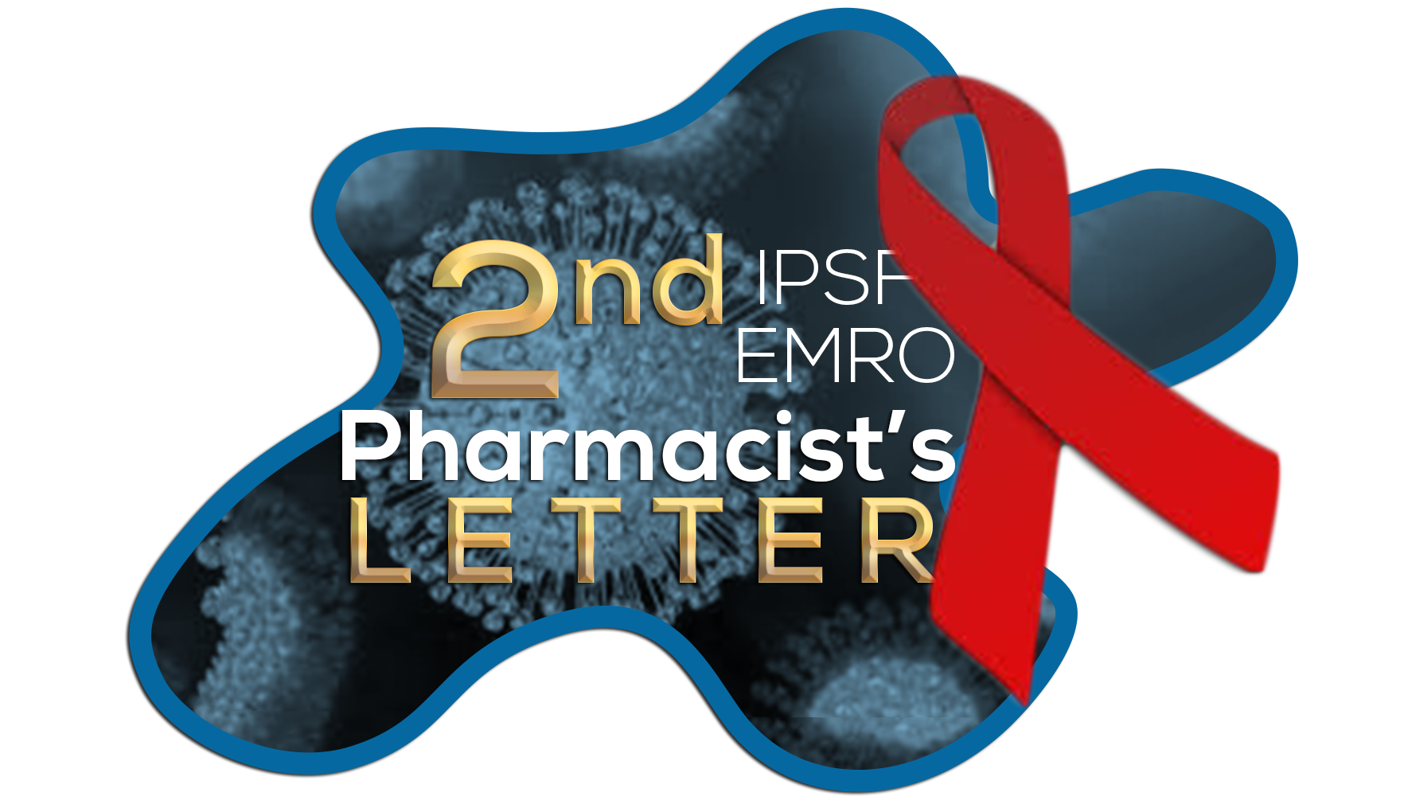
Human immunodeficiency virus (HIV)

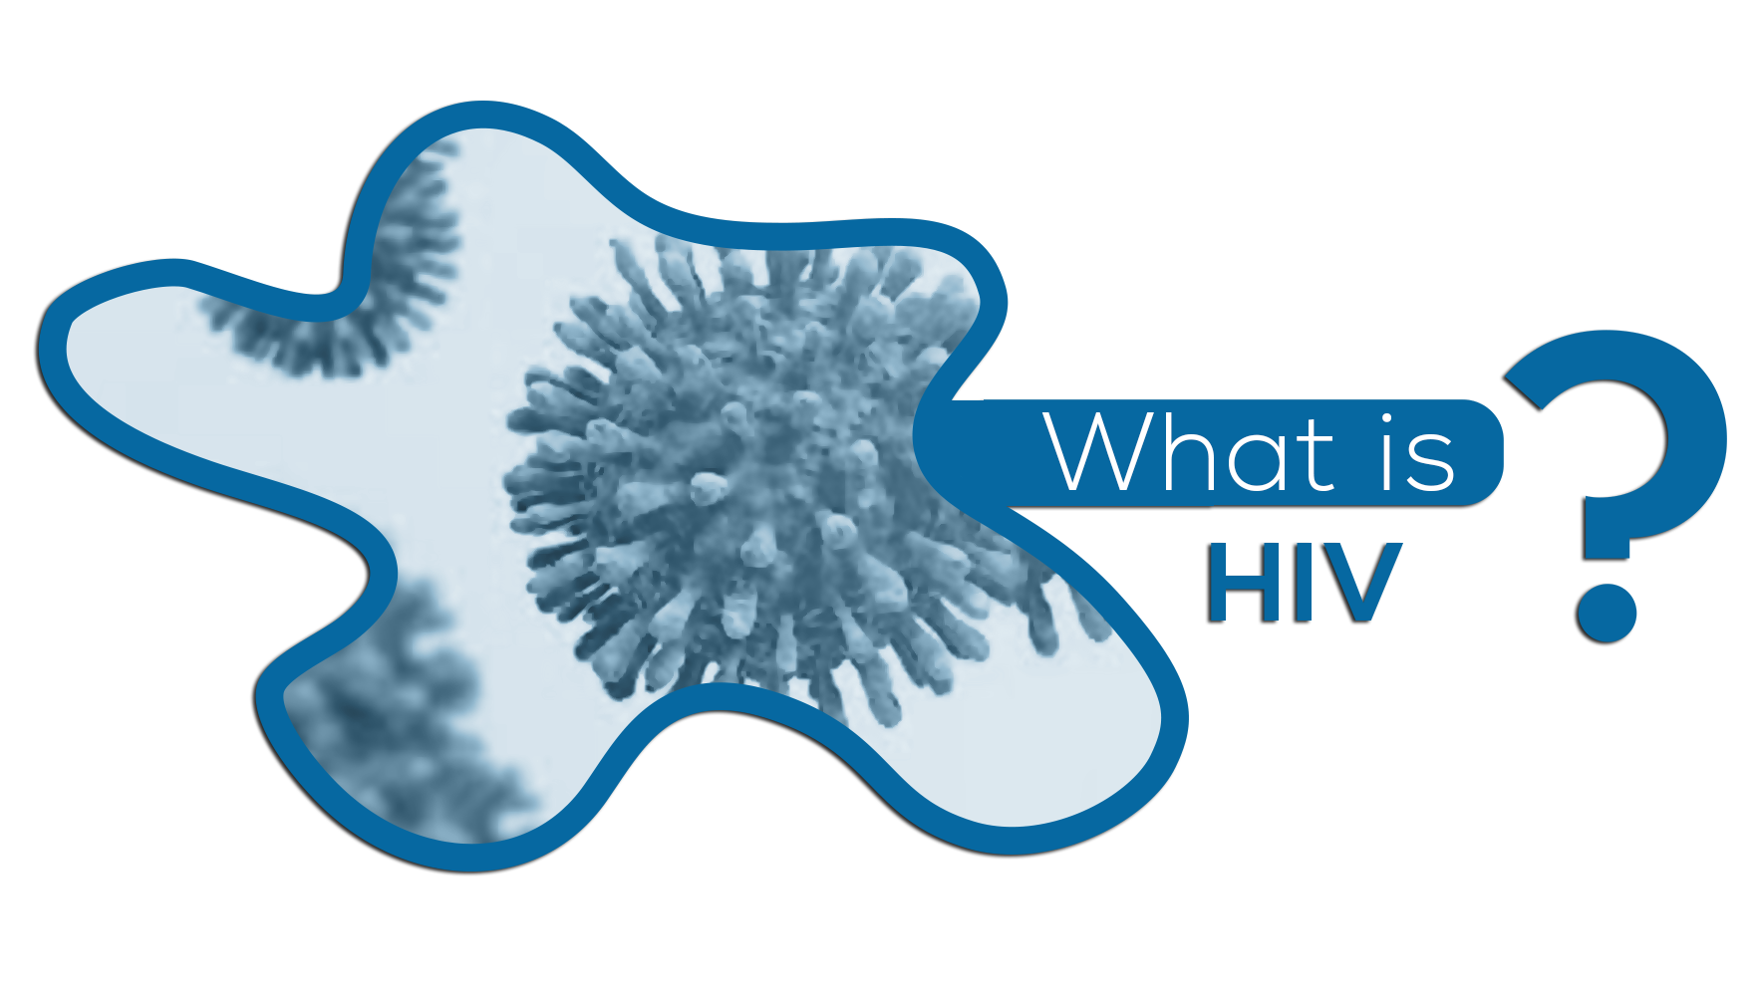

Human immunodeficiency virus (HIV) is an infection that attacks the body’s immune system, our body’s natural defenses against illnesses, specifically the white blood cells called CD4 cells weakening a person’s immunity against life-threatening infections and diseases such as tuberculosis and some cancers.
HIV is transmitted through contact with blood, semen, breast milk, or other bodily fluids that contain the virus.
If the person’s CD4 cell count falls below 200, their immunity is severely compromised, leaving them more susceptible to infections and the person is described as having Acquired immunodeficiency syndrome (AIDS).
There’s currently no known cure for HIV. However, antiretroviral treatment if taken consistently can help people living with HIV manage the condition and lead healthy lives by controlling the growth of the virus, Improving how well your immune system works, Slowing or stopping symptoms & Preventing transmission of HIV to others.
In the following Pharmacist's Letter you will know more about antiretrovirals, the latest guidelines on HIV medication and how to counsel HIV Patients.

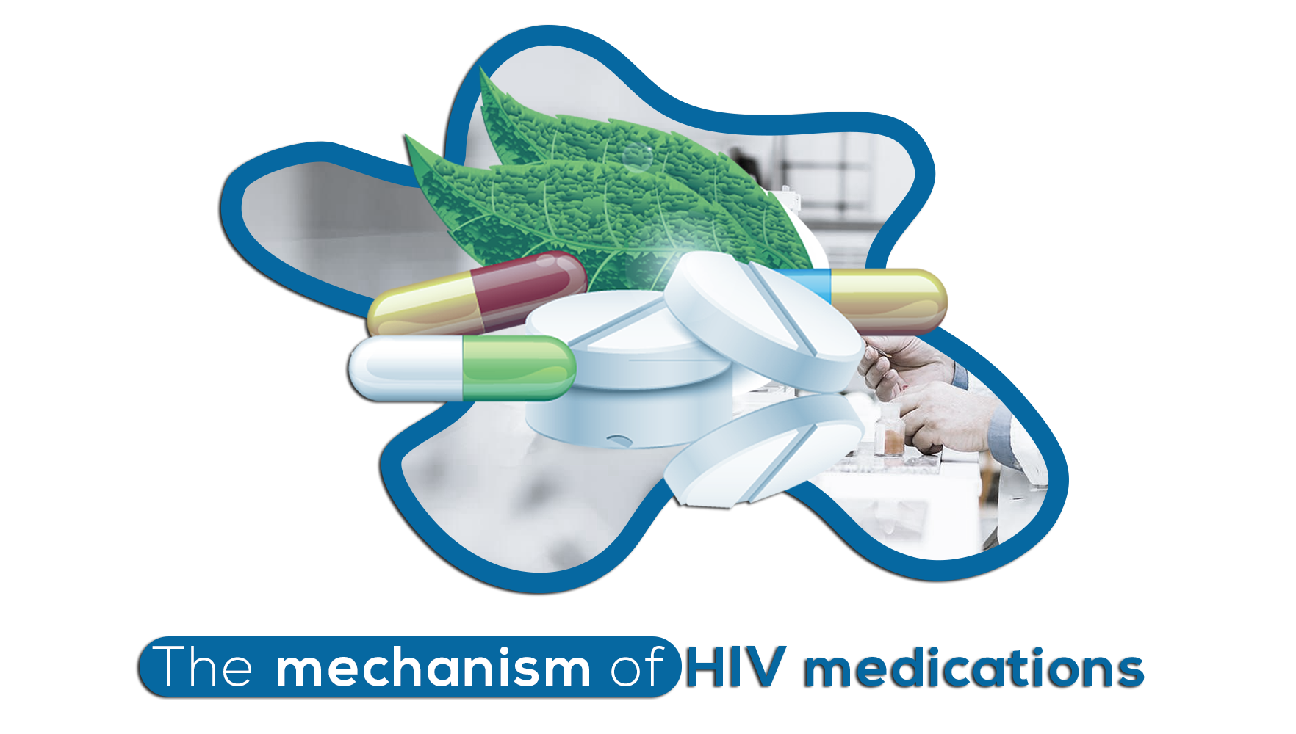
HIV is a retrovirus, and through antiretroviral molecules we can prevent the HIV virus from making copies of itself and limits how much virus is in the body. Antiretrovirals are recommended for all people with HIV, regardless of how long they’ve had the virus or how healthy they are, making HIV manageable through lifelong treatment.
The level of virus in the blood is called ‘viral load’. When the viral load is low or “undetectable”, there is less harm to the body’s immune system and fewer complications of HIV infection. Reducing the viral load to undetectable levels also greatly reduces the chance of passing HIV to partners.
Here’s a list of antiretrovirals, that are currently approved by the Food and Drug Administration (FDA) to treat HIV. They're often broken into six groups because they work in different ways.

Know more about HIV medications and their mechanism in the following table!
Medication |  | Mechanism of action
Integrase strand transfer inhibitors (INSTIs): raltegravir, dolutegravir, elvitegravir, bictegravir |  | IThey stop the action of Integrase, a viral enzyme that HIV uses to infect T cells by putting HIV DNA into human DNA.
Nucleoside/Nucleotide reverse transcriptase inhibitors (NRTIs and NtRTIs):  adefovir, entecavir, telbivudine, didanosine, tenofovir, lamivudine, zidovudine, abacavir, stavudine, emtricitabine |  | Sometimes referred to as “nukes.” They work by interrupting the life cycle of HIV as it tries to copy itself. These drugs also have other actions that prevent HIV from replicating in the body.
Non-nucleoside reverse transcriptase inhibitors (NNRTIs): nevirapine, etravirine, efavirenz, rilpivirine, delavirdine, doravirine |  | These drugs work in a similar way to NRTIs. They stop the virus from replicating itself in the body.
Protease inhibitors (PIs): Atazanavir, Darunavir, Fosamprenavir, Indinavir, Lopinavir, Nelfinavir, Ritonavir, Saquinavir, Tipranavir |  | PIs work by binding to the enzyme protease. HIV needs protease to replicate in the body. When protease can’t do its job, the virus can’t complete the process that makes new copies. This reduces the number of viruses that can infect more cells.
Fusion inhibitors: enfuvirtide |  | Fusion inhibitors are another class of HIV medication.  HIV needs a host T cell to make copies of itself. Fusion inhibitors block the virus from entering a host T cell. This prevents the virus from replicating itself.
Entry inhibitors: | All entry inhibitors work by blocking the virus from entering healthy T cells. These drugs are rarely used as first-line treatments for HIV.
 | Post-attachment inhibitors / Monoclonal antibodies:  Ibalizumab-uiyk | Because HIV affects the immune system, researchers have been studying ways that biological drugs can prevent viral replication. Certain immune-based treatments have seen some success in clinical trials.
 | Chemokine coreceptor antagonists (CCR5 antagonists):  maraviroc | Chemokine coreceptor antagonists, or CCR5 antagonists, block HIV from entering cells. CCR5 antagonists are rarely used in the United States because other available drugs are more effective, and this medication requires special testing prior to its use.

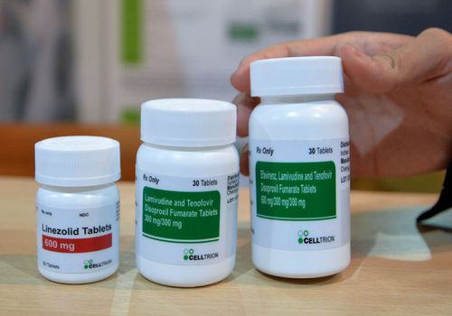

- Highly active antiretroviral therapy (HAART):
However, the use of one or two antiretroviral drugs had generally limited success in patients with HIV, resulting in rapid treatment failure as well as the inability to fully suppress viral activity.
Doctors recommend a combination of 3 or more drugs to have the greatest chance of lowering the HIV viral load in your body. This is what we call Highly active antiretroviral therapy (HAART).

There are six major classes of HIV ARVs available for use in HAART (Highly Active Antiretroviral Therapy): nucleoside reverse transcriptase inhibitors (NRTIs), non-nucleoside reverse transcriptase inhibitors (NNRTIs), PIs, fusion inhibitors, integrase inhibitors, and chemokine receptor (CCR5) antagonists.
Today HAART is easy to take and the number of pills needed is less than in the past, allowing high levels of drug adherence.
- Treatment as prevention (TasP):
Treatment as prevention (TasP) refers to the use of antiretroviral (ARV) medication to prevent HIV transmission. TasP involves prescribing ARVs to those who are living with HIV in order to reduce the amount of virus in their blood to undetectable levels so that there is effectively no risk of transmission of HIV.

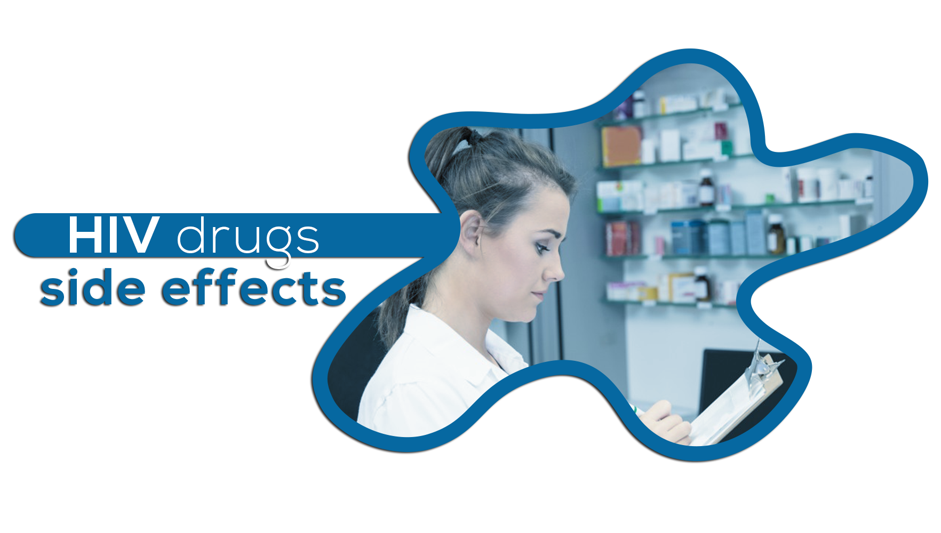

Many HIV drugs can cause temporary side effects when first used. In general, these effects can include:

- diarrhea
- dizziness
- headaches
- fatigue
- fever
- nausea
- rash
- vomiting

These drugs may cause side effects for the first several weeks. If the side effects get worse or last longer than a few weeks, consider talking to a healthcare provider. They may suggest ways to ease the side effects, or they may prescribe a different drug altogether.
Less often, HIV drugs can cause serious or long-term side effects. These effects depend on the type of HIV drugs used. A healthcare provider can offer more information.

To have information on the side effects of each antiretroviral drug, kindly check the following link.
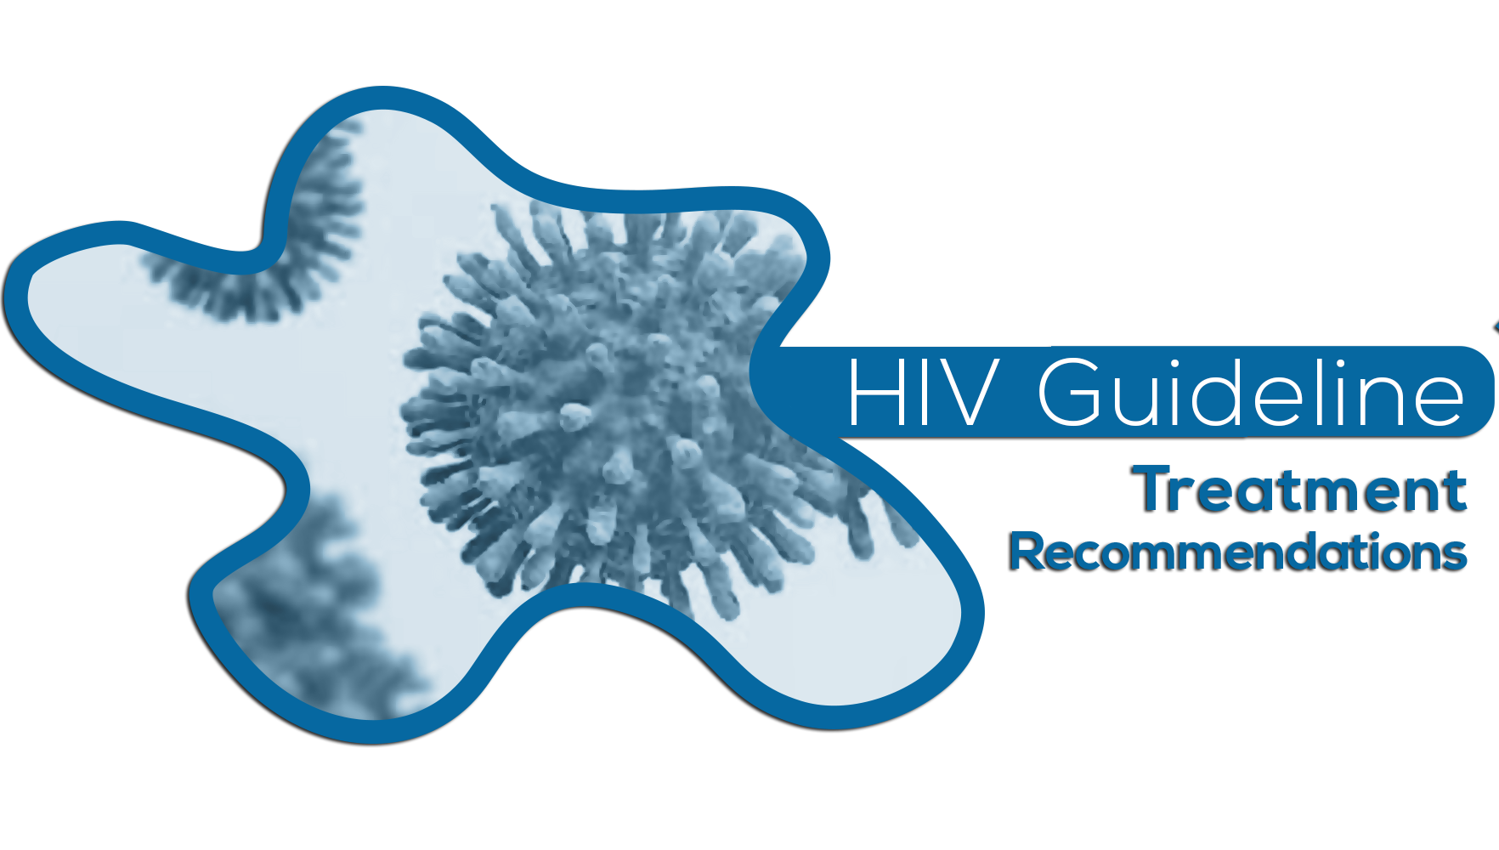
The availability of more treatment options for HIV has made management of infections easier than ever before and the selection of antiretroviral therapy should be based on updated guideline recommendations.
Several guidelines on the treatment and management of HIV infection are avail­able, including but not limited to those by the US Department of Health and Human Services (DHHS), the International Antiviral Society–USA Panel (IAS–USA), the European AIDS Clinical Society (EACS), the British HIV Association (BHIVA), and the World Health Organization.
These guidelines are routinely updated to reflect the current literature available.

Kindly find in this table the available guidelines for the recommended initial regimens and Alternative Regimens for HIV Positive Adults and Adolescents, and the links to these guidelines:
Guidelines | Last updated | Recommended Initial regimens | Alternative Regimens
DHHS: US Department of Health & Human Services | May 2018  Link | - BIC/FTC/TAF  - DTG/ABC/3TC  - DTG + FTC/(TAF or TDF)  - EVG/c/FTC/(TAF or TDF)  - RAL + FTC/(TAF or TDF) | - DRV/c or DRV/r + FTC/(TAF or TDF)  - ATV/c or ATV/r + FTC/(TAF or TDF)  - DRV/c or DRV/r + ABC/3TC  - ATV/c or ATV/r + ABC/3TC  - EFV + FTC/(TAF or TDF)  - RPV + FTC/(TAF or TDF)  - RAL + ABC/3TC  - DRV/r + RAL  - LPV/r + 3TC
IAS-USA: International Antiviral Society–USA Panel | July 2018  Link | - BIC/FTC/TAF  - DTG/ABC/3TC  - DTG + FTC/TAF | - DRV/c or DRV/r + FTC/(TAF or TDF)  - EFV/FTC/TDF  - EVG/c/FTC/(TAF or TDF)  - RAL + FTC/(TAF or TDF)  - RPV/FTC/(TAF or TDF)
EACS: European AIDS Clinical Society | October 2017  Link | - DTG/ABC/3TC  - DTG + FTC/(TAF or TDF)  - EVG/c/FTC/(TAF or TDF)  - RAL + FTC/(TAF or TDF)  - DRV/c or DRV/r + FTC/(TAF or TDF)  - RPV/FTC/(TAF or TDF) | - RAL + ABC/3TC  - EFV/FTC/TDF  - EFV + ABC/3TC  - ATV/c or ATV/r + FTC/(TAF or TDF)  - ATV/c or ATV/r + ABC/3TC  - DRV/c or DRV/r + ABC/3TC  - DRV/c or DRV/r + RAL
BHIVA: British HIV Association  Link | 2016 interim update  Link | - DTG + FTC/(TAF or TDF)  - EVG/c/FTC/(TAF or TDF)  - RAL + FTC/(TAF or TDF)  - DRV/r + FTC/(TAF or TDF)  - ATV/r + FTC/(TAF or TDF)  - RPV/FTC/(TAF or TDF) | - EFV/FTC/TDF  - DTG/ABC/3TC  - EVG/c + ABC/3TC  - RAL + ABC/3TC  - DRV/r + ABC/3TC  - ATV/r + ABC/3TC  - RPV + ABC/3TC
WHO: World Health Organization | July 2018  Link | - DTG + TDF + 3TC or FTC  - EFV + TDF + 3TC or FTC | - EFV or NVP + AZT + 3TC  - EFV400 + TDF + 3TC or FTC  - NVP + TDF + 3TC or FTC

ABC indicates abacavir; ATV, atazanavir; AZT, zidovudine; BIC, bictegravir; c, cobicistat; DRV, darunavir; DTG, dolutegravir; EFV, efavirenz; EVG, elvitegravir; FTC, emtricitabine; LPV, lopinavir; NVP, nevirapine; r, ritonavir; RAL, raltegravir; RPV, rilpivirine; TAF, tenofovir alafenamide; TDF, tenofovir disoproxil fumarate; 3TC; lamivudine.

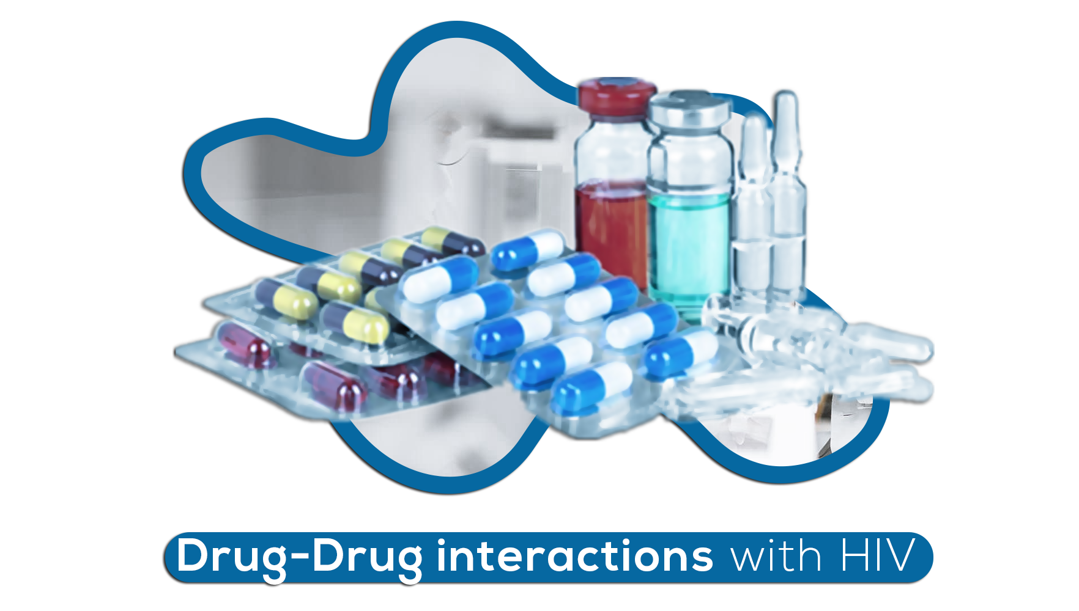

Antiretroviral therapy:

Drug-drug interactions with HAART, particularly PI- and NNRTI-based regimens, often complicate the management of patients with HIV.
Many of these drug interactions are mediated through the CYP450 system -an enzyme in the liver that helps several functions in the body, including breaking down or metabolizing medications- particularly the CYP3A4 isoenzyme. PIs, NNRTIs, and maraviroc are metabolized through this same system; thus, they are highly susceptible to drug interactions.
Therefore, any concomitant drugs that act as an inhibitor or inducer of the CYP450 system can alter the serum concentrations of these ARVs. Additionally, PIs can inhibit CYP3A4 isoenzymes and NNRTIs (Efavirenz, Nevirapine) can induce the same isoenzyme and affect concentrations of other drugs that are coadministered with them.
As a clinician, it is imperative to understand these drug interactions and commonly prescribed medications in the HIV patient population in order to prevent drug toxicities, virologic failure, or death in patients with HIV.

Known Interactions with HIV drugs

Statins:

HIV drugs, PIs particularly have been associated with long term metabolic complications (e.g., lipodystrophy, dyslipidemia, diabetes mellitus.), the dyslipidemia can also be caused by the infection itself, which means that HIV patients might require treatment of their dyslipidemia with lipid-lowering therapy (Statins, Fibrates, Ezetimibe, Niacin).

But many statins are metabolized by the CYP450 system, specifically the CYP3A4 isoenzyme (except fluvastatin, pravastatin & rosuvastatin) and drug interactions are inevitable with drugs metabolized by the same enzyme.

- In association with the drugs that inhibit the CYP450 system, the AUC of statins is increased which could increase the patient's risk for adverse effects such as myalgias, rhabdomyolysis, elevated creatinine phosphokinase (CPK), and hepatic dysfunction.

- In association with the drugs that induces the CYP450 system: will probably require higher doses of interacting statins in order to achieve optimal lipid-lowering effects.

Antiretroviral | Coadministered drug | Mechanism involved | Effect | Recommendation
PIs & delavirdine | Simvastatin, Lovastatin | CYP ENZYME INVOLVED: 3A4 | Increases AUC | Avoid
PIs & delavirdine | Atorvastatin | CYP ENZYME INVOLVED: 3A4 | Increases AUC | Start with atorvastatin 10mg daily, titrate slowly to achieve the necessary lipid-lowering effect, monitor
Efavirenz & Etravirine | Simvastatin, Atorvastatin | CYP ENZYME INVOLVED: 3A4 | Decreases AUC | Standard dose, titrate to effect
PIs & delavirdine | Fluvastatin | CYP ENZYME INVOLVED: 2C9 | Probably not significant | Standard dose, titrate to effect
Etravirine | Fluvastatin | CYP ENZYME INVOLVED: 2C9 | Increases AUC | Start with low-dose fluvastatin and titrate slowly, monitor
PIs & delavirdine & Efavirenz | Pravastatin | - | Decreases AUC | Standard dose, titrate to effect
Lopinavir/Ritonavir, Tipranavir/ritonavir | Rosuvastatin | <10% by CYP450 system, mechanism unclear | Increases AUC | Caution- may be able to start with low-dose rosuvastatin; further evaluation with other PIs needed
the statins recommended for use in HIV patients on a PI-based regimen are atorvastatin, fluvastatin, and pravastatin

Antiepileptics:

The first-generation AEDs (i.e., carbamazepine, phenytoin, phenobarbital) are substrates as well as inducers of the CYP450 system.
Since PIs, NNRTIs, and maraviroc are metabolized through the same pathways, the potential exists for significant drug interactions.

Additionally Valproate & Stiripentol act as CYP3A4 isoenzyme Inhibitors, while the following are Inducers: Phenytoine, Fosphénytoine, Primidone, Phénobarbital, Carbamazepine.

When the AEDs metabolism is decreased its AUC increases and subsequently its toxicity increases.

When the AEDs metabolism is increased, the reduction in the anticonvulsant serum concentrations can lead to seizures.

Antiretroviral | Coadministered drug | Mechanism involved | Effect | Recommendation
PIs, Maraviroc, delavirdine, efavirenz, etravirine | Carbamazepine, phenytoin, phenobarbital | Induction of CYP450 system by Antiepileptic drug | DecreasesAUC of Antiretroviral | Monitor for virologic failure
PIs | Carbamazepine | Inhibition of CYP450 system by PIs | Increases AUC | Monitor AntiEpileptic Drug level
Efavirenz & Nevirapine | Carbamazepin | CYP ENZYME INVOLVED: 3A4 | Decreases AUC | Monitor AntiEpileptic Drug level
Lopinavir/ritonavir, nelfinavir | Phenytoin | CYP ENZYME INVOLVED: 2C9/19 | Decreases AUC | Monitor AntiEpileptic Drug level

PDE-5 Inhibitors

Erectile dysfunction is a common occurrence among HIV infected men, who might require using PDE-5 inhibitors.
Therefore, PDE-5 inhibitors are metabolized through the CYP450 3A4 isoenzyme leading to inevitable interactions with ARV, increasing the AUC of PDE-5 inhibitors.
Potential consequences of increased concentrations of PDE-5 inhibitors include hypotension, dizziness, and priapism.
Antiretroviral | Coadministered drug | Mechanism involved | Effect | Recommendation
PIs & delavirdine | Sildenafil, Vardenafil, Tadalafil | CYP ENZYME INVOLVED: 3A4 | Increases AUC | Sildenafil dose should not exceed 25mgin 48hours  Start tadalafil at 5mg and do not exceed 10mg in 72hours  Start vardenafil at 2,5mg for 24hours  Ritonavir based regimens should not exceed 2,5mg over 72hours

Acid-suppressive therapy:

Acid-suppressive therapy with histamine-2 (H2) blockers, proton pump inhibitors (PPIs), or antacids can cause a decrease in the absorption of some PIs and delavirdine due to changes in the pH of the gastrointestinal tract.

Some PIs (e.g., indinavir) are able to overcome this alteration in absorption through boosting with ritonavir.

However, other PIs (e.g., atazanavir, fosamprenavir, tipranavir) have been found to have significant interactions with acid-suppressive therapy that requires intervention due to the potential for virologic failure from inadequate ARV concentrations.

Antiretroviral | Coadministered drug | Mechanism involved | Effect | Recommendation
Atazanavir/ritonavir | Proton Pomp inhibitors (PPI), antiacids, H2 Blockers | Altered Absorption | Decreases AUC ARV | Monitor for virologic failure
Fosamprenavir | H2 blockers | Altered Absorption | Decreases AUC ARV | Monitor for virologic failure
Tipranavir/ritonavir | Antiacids | Altered Absorption | Decreases AUC ARV | Monitor for virologic failure
Delavirdine | Proton Pomp inhibitors (PPI), antiacids, H2 Blockers | Altered Absorption | Decreases AUC ARV | Monitor for virologic failure
It is recommended that the ARV be given either one to two hours before or one hour after the administration of the antacid.

Methadone
Methadone, commonly prescribed for HIV patients for the treatment of pain or drug addiction, interacts with most PIs and NNRTIs through several complex mechanisms, including the induction of the CYP450 system and glucuronyltransferase, changes in plasma protein binding, induction of P-glycoprotein.
Antiretroviral | Coadministered drug | Mechanism involved | Effect | Recommendation
Lopinavir/ritonavir, nelfinavir (potentially other PIs); efavirenz, nevirapine | Methadone | CYP ENZYME INVOLVED: 3A4 | Decreases AUC | Increase dose 10mg at a time, monitor for opioid withdrawal
Delavirdine | Methadone | CYP ENZYME INVOLVED: 3A4 | Increases AUC | Titrate to effect, dosage reduction may be necessary

Antidepressants
Depression is a frequent disorder among HIV patients.

Antidepressants include selective serotonin reuptake inhibitors, tricyclic antidepressants (TCAs), monoamine oxidase inhibitors, and other new atypical drugs.

When coadministering antidepressants and either a PI- or NNRTI-based HAART regimen, antidepressants should be initiated at a low dose and titrated over several weeks. Patients should also be closely monitored for adverse effects.
Antiretroviral | Coadministered drug | Mechanism involved | Effect | Recommendation
PIs and delavirdine | Trazodone | CYP ENZYME INVOLVED: 3A4 and 2D6 | Increases AUC (can cause diarrhea and dizziness) | Start with low-dose trazodone, titrate to effect, monitor
For more information on the treatment of HIV patients with psychotropic medications you can check the following article: https://academic.oup.com/cid/article/42/9/1305/315936

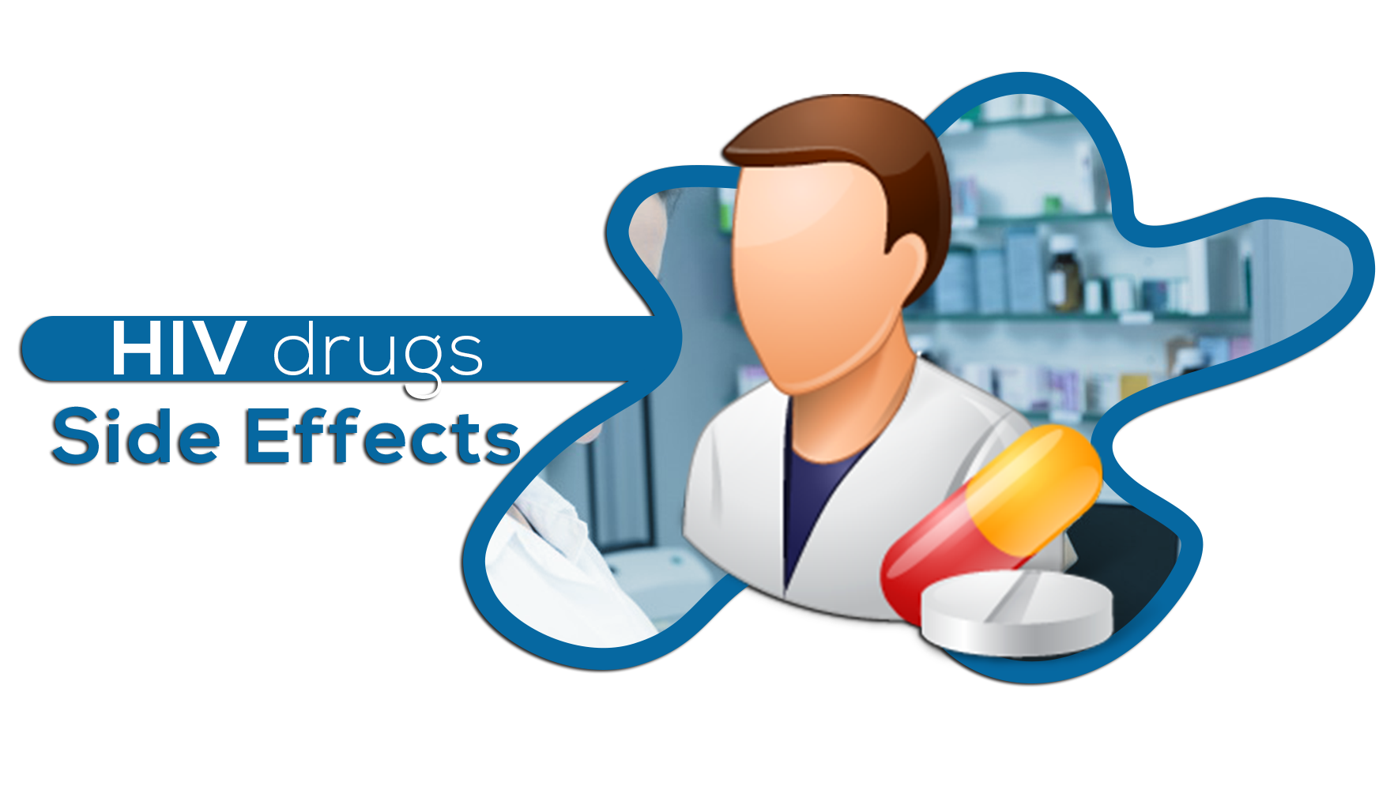

Counseling in HIV and AIDS has become a core element in a holistic model of health care, in which psychological issues are recognized as integral to patient management. HIV and AIDS counseling has two general aims:
- Prevention of HIV transmission
Up to now, there's no vaccine to prevent HIV infection and no cure for AIDS. But you can protect yourself and others from infection.
To help prevent the spread of HIV:
- Use a new condom every time you have sex, whether anal or vaginal sex. Women can use a female condom. If using a lubricant, make sure it's water-based. Oil-based lubricants can weaken condoms and cause them to break. During oral sex use a non-lubricated, cut-open condom or a dental dam — a piece of medical-grade latex.
- Consider preexposure prophylaxis (PrEP). The combination of drugs emtricitabine plus tenofovir (Truvada) and emtricitabine plus tenofovir alafenamide can reduce the risk of sexually transmitted HIV infection in people at very high risk.
Your doctor will prescribe these drugs for HIV prevention only if you don't already have HIV infection. You will need an HIV test before you start taking PrEP and then every three months as long as you're taking it. Your doctor will also test your kidney function before prescribing Truvada and continue to test it every six months.
You need to take drugs every day. They don't prevent other STIs, so you'll still need to practice safe sex. If you have hepatitis B, you should be evaluated by an infectious disease or liver specialist before beginning therapy.
- Tell your sexual partners if you have HIV. It's important to tell all your current and past sexual partners that you're HIV-positive. They'll need to be tested.
- Use a clean needle. If you use a needle to inject drugs, make sure it's sterile and don't share it. Take advantage of needle-exchange programs in your community and consider seeking help for your drug use.
- If you're pregnant, get medical care right away. If you're HIV-positive, you may pass the infection to your baby. But if you receive treatment during pregnancy, you can cut your baby's risk significantly.
- Consider male circumcision. There's evidence that male circumcision can help reduce the risk of getting HIV infection.

- Supporting persons infected by HIV:
There are many things that you can do to help a friend or loved one who has been recently diagnosed with HIV:
- Talk. Be available to have open, honest conversations about HIV. Follow the lead of the person who is diagnosed with HIV. Show them that you see them as the same person and that they are more than their diagnosis.
- Listen. Being diagnosed with HIV is life-changing news. Listen to your loved one and offer your support. Reassure them that HIV is a manageable health condition.
- Learn. Educate yourself about HIV: what it is, how it is transmitted, how it is treated, and how people can stay healthy while living with HIV.
- Encourage treatment. Some people who are recently diagnosed may find it hard to take that first step to HIV treatment. Your support and assistance may be helpful. By getting linked to HIV medical care early, starting treatment with HIV medication, adhering to medication, and staying in care, people with HIV can keep the virus under control, and prevent their HIV infection from progressing to AIDS.
- Support medication adherence. It is important for people living with HIV to take their HIV medication every day, exactly as prescribed.
- Get support. Take care of yourself and get support if you need it. Turn to others for any questions, concerns, or anxieties you may have so that the person who is diagnosed can focus on taking care of their own health.

- Guideline Updates for the Treatment of Adolescents and Adults With HIV: OCT 17, 2018 | AMY C. MIN, PHARMD, BCACP, AAHIVP https://www.contagionlive.com/publications/contagion/2018/october/guideline-updates-for-the-treatment-of-adolescents-and-adults-with-hiv?fbclid=IwAR3e9mW8bHpHhb8RWaXZUQ5lMDhLjdFQr25uBgvAsw1_tdQbAMMvsy4Iohw
- HIV Guidelines Treatment recommendations: https://contagion.s3.amazonaws.com/_media/_thumb/October_HIV_Table_1018.pdf
- HIV Treatment on the CDC Website, Page last reviewed: October 17, 2019: https://www.cdc.gov/hiv/basics/livingwithhiv/treatment.html?fbclid=IwAR0y8YbDr-ojDPDhb9a6Vam5x73Sl_DnWJ8mYGXPWjQA3f9ALz8wNsghRQY
- HIV/AIDS Treatment on AIDSinfo website: https://aidsinfo.nih.gov/guidelines?fbclid=IwAR0nF9XWaSsjzItU5nPfjDRNK4GtncaB84k8PtI9s1Pxq24WM83cm-hjz4A
- “Updated recommendations on first-line and second-line antiretroviral regimens and post-exposure prophylaxis and recommendations on early infant diagnosis of HIV” on WHO Website: https://www.who.int/hiv/pub/guidelines/ARV2018update/en/?fbclid=IwAR12dHyFB4BYHJfQNITrlRrA7MWc4iSES_Aeuh9DmIgegaXvQNTjUK0h-o4
- https://apps.who.int/iris/bitstream/handle/10665/273632/WHO-CDS-HIV-18.18-eng.pdf?ua=1
- “Does HIV Treatment as Prevention work?” https://www.verywellhealth.com/hiv-treatment-as-prevention-49133
- https://www.webmd.com/hiv-aids/aids-hiv-medication#1
- https://aidsinfo.nih.gov/drugs
- https://www.cdc.gov/hiv/guidelines/
- https://www.cdc.gov/hiv/basics/livingwithhiv/treatment.html?fbclid=IwAR0y8YbDr-ojDPDhb9a6Vam5x73Sl_DnWJ8mYGXPWjQA3f9ALz8wNsghRQY
- https://aidsinfo.nih.gov/guidelines/html/1/adult-and-adolescent-arv/0
- https://academic.oup.com/cid/article/42/9/1305/315936
- https://www.uspharmacist.com/article/drugdrug-interactions-with-hiv-antiretroviral-therapy

